Dr.Sachchidanand Sinha
NATURE & SCOPE OF ECONOMICS
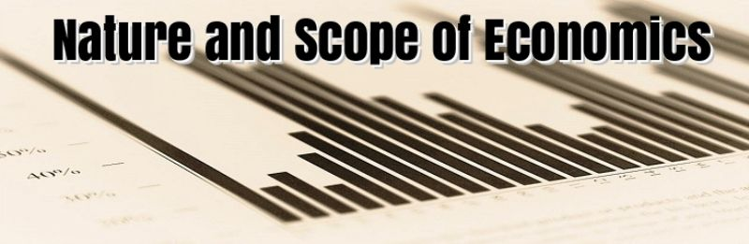
Those days are gone, when people weren’t aware of the three basic rules of doing business. Nowadays, the tables have turned around. As, everybody wants to flourish their business to an apex level, for this, the understanding of economic concept is mandatory for all of us.
Introduction to Economics
Meaning of economics has been interpreted differently by different individuals. According to the Adam smith’s definition of economics, the concept of Economics is a wealth oriented. In his definition, a man is always looking to increase his economic profit. While on the other hand, Alfred Marshall says that economics is not only about money but also connected with business too. According to him, spending money is also as important as earning. Though, there are infinite numbers of explanation by various philosophers.
In simplest term, Economics is related to the aspects that determine the consumption, production, exchange and distribution of various goods and services. Well, the importance of economics as a subject is extensive and varied. The nature and scope of Economics mainly depend on the activities of economics agents and how their economics effort. To understand the economics in a detailed manner, then it’s time to analyze the nature of economics deeply.
Nature of Economics
When it comes to the nature of economics, there are several things that strike the doors of our mind, i.e. whether the economics is considered as a science or an art. This matter has always been in the great argument regarding various economists. But, now it’s time to lift up the curtains to find out about the nature of economics.
- Economics as a science: Before getting deep into the context of this topic, firstly it is significant to have an impression about science. It is mainly defined as the systematic study that signifies the cause and effect relationship. In science, it is the collection of facts and figures that should be analyzed correctly. Economics, yet, is treated as a social science due to these following features of science.

  - It depends on the systematic collection and analysis of facts and figures. Likewise, in economics, all the theories connected with micro and macroeconomics is examined carefully.
  - It is based on the formulation of theories and laws,
  - It believes in tracing the cause and effect relationship.
  - It can also make upcoming forecasts.
  - It has a scale of measurement, as in economics, ‘money’ is considered as the measuring rod.
From the above-mentioned points, it can be clearly stated that the nature of economics is correlated to science. Alike in science, various economic theories are based on logical reasoning. Let’s take an example to understand this. In science, there is Newton’s law of gravitation and in economics; law of demand signifies that there will be rise in demand if it is decreasing in price.
- Economics as an art: Now, the question arises why nature of economics is an art? According to the Marshall, art is the application of information and knowledge. As, in economics, art acts as a solution to all economic complications. Furthermore, there are several terms in economics like distribution, consumption, and production that offer the guidelines to us, that can be used to sort out the economic problems in society.
Thus, from the above discussion, it can be clearly said that the economics is both a science and an art.
Scope of Economics
The basic concept of economics has a very vast scope and to understand this crucial aspect, it is really necessary to go through this concern very carefully.so, without wasting time, let’s go and comprehend it.
Scope of economics can be classified broadly into two categories:
- Microeconomics: Microeconomics is the study of examining every individual economic activity, industries, and their interaction. It mainly observes how a person earns and spends his income. Besides it, the nature of microeconomics has certain key areas that must be taken into consideration.

  - Elasticity: Elasticity is used to determine the ratio of change in the proportion of one variable to the change in the proportion of another variable. Commonly used elasticity in the market: price elasticity of demand, the income elasticity of demand, the price elasticity of supply etc.
  - Theory of production: In this study of production, the input is converted into output efficiently. Production can include storing, shipping, packaging, and manufacturing.
  - Cost of production: In this theory, it states that the object price is determined by the price of resources. The cost can be comprised of land, labor, capital and technology.
  - Monopoly: A monopoly can be defined as the state where a single firm is the one and only supplier of a specific commodity.
  - Economics of Information: Information economics is a kind of theory, which shows how information can affect economic decisions.
  - Oligopoly: It is termed as the situation where the small numbers of sellers dominate an industry or a market.
- Macroeconomics: It is the branch of economics, which deals with the economic functioning and its performance, decision making, and structure as a whole. However, there are some basic concepts of nature and scope of macroeconomics that makes it more interesting than any other.

  - Output and income: Output can be defined as the total income that generates from the sold commodity. It is usually measured by the Gross Domestic Product (GDP). Moreover, there are many reasons for the rise in output: technological advancement, human capital, and better education.
  - Unemployment: It is typically measured by the overall employment rate, which means the ratio of workers without employment in the workforce. But the people who are pursuing their education and retired are excluded from this unemployment rate.
  - Inflation and deflation: In general terms, increase in price refers to inflation; while on the other hand, decrease in price refers to deflation in the economy. These fluctuations in the price can be easily measured by using price indexes.
